Power Bi- capstone project  
 Olympics data analysis

**1. How many Olympic Games have been held in each season (Summer vs. Winter)?**

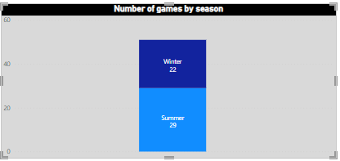

**The olympic games have been held in two different seasons like: Summer and winter.**

**From the above visualisation we are get to know that the more events occurred in the summer season**

**rather than winter.**

1. **What is the distribution of games across different decades?**

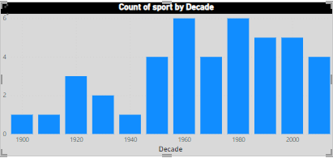

**The above chart shows the up and down of the games for the each decade. We could see in the year 1960 and 1980 have the more no.of events.**

1. **Which cities have hosted the most Olympic Games?**

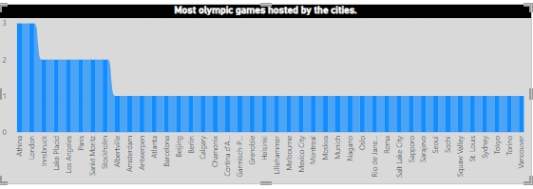

**Athina and London hold the record for the most Olympic Games hosted, with each city hosting three times.**

1. **What is the distribution of sports between Summer and Winter Olympics?**

Summer Winter

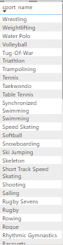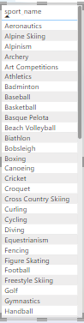**The distribution of sports between summer and winter are shown here:**

The summer olympic games is an international multi-sport event

Occurring every four years.

The first summer olympic are held in the

Athens, greece in 1896.

The winter olympic games is a major international sporting event

That occurs once every four years.

The first winter olympic games are held in the

Chamonix, france in 1924.

1. **Which sports have the highest number of events in the Olympics?**

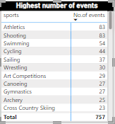

**In the Olympic Games, various sports take centre stage to showcase incredible diversity of human abilities and talents.**

**On those I have found some of the sports named Athletics, shooting, Swimming, cycling, sailing. Which have highest number of events overall.**

1. **How has the participation in each sport evolved over time?**

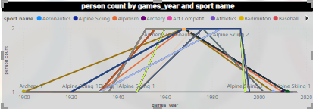

**7. How many events are there in each sport?**

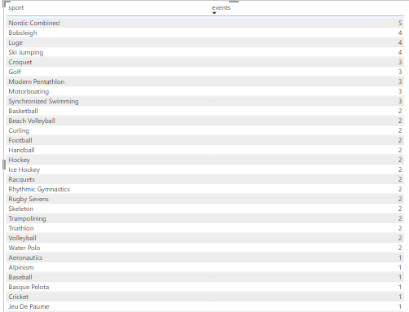

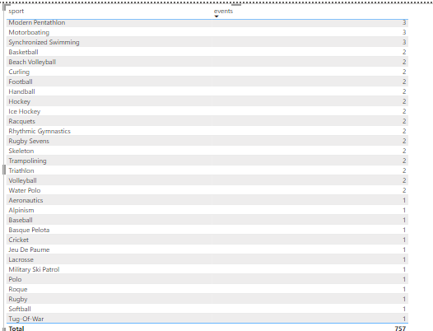

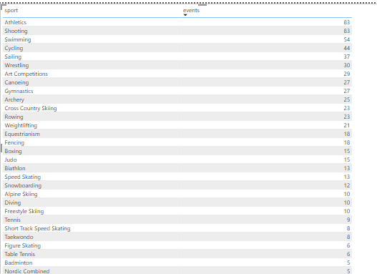

1. **What is the distribution of events by gender (Men, Women, Mixed)?**

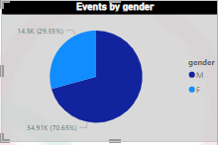

**Athletes should be allowed to compete**

**In the category the best aligns with their self-determined gender**

**Identity, provided the meet relevant eligibility criteria.**

1. **How has the number of events changed over time?**

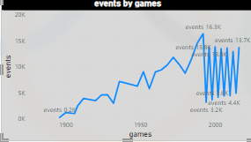

**The number of events in the Olympic Games has changed significantly over time. Here is an overview of howthe number of events has evolved across all years.**

**In 1896, there were 217 events. The number of events increased over subsequent years, with fluctuations. The number reached its peak in 2016 with 13,685 events.**

1. **What is the distribution of participants by gender?**

**The distribution of participants by gender in the Olympic Games is as follows:**

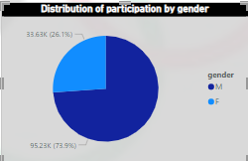 **Male participants (M): 95,225 Female participants (F): 33,629**

1. Which countries have the highest number of participants in the Olympics?

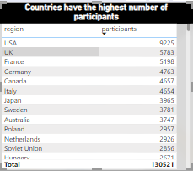

1. **How does the age distribution of participants vary across different games?**

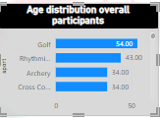

1. How many medals have been awarded in each Olympics?

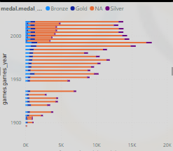

1. **Which countries have the highest number of gold medals?**

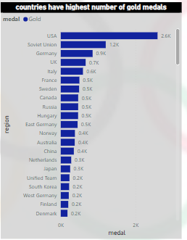

**By seeing the visualisation USA got most number of gold medals.**

1. **How does the medal distribution vary across different sports?**

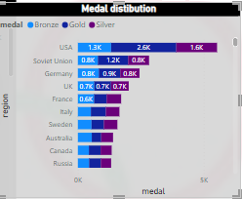

**By seeing the vary across medal distribution.**

**The USA won the most number of gold, silver, bronze medals.**

1. **How many regions or NOCs participate in each Olympic Games?**

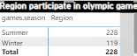 **In summer olympic games total 228 regions are partipated, while in winter olympics games 119 regions are participated.**

1. 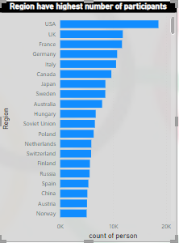**Which regions have the highest number of participants in the Olympics?**

**From the country USA the highest number of participants**

**are involved in the olympics.**

1. **What is the distribution of medals among different regions?**

**The United States holds the top position due to its consistent dominance across all three medal categories.**

